CUSOTM DASHBOARD VIEW
STOCK SEARCH BAR

BUTTONS:
- ADD SALE > LIST SALE
- ADD PURCHASE > LIST PURCHASE
- ADD STOCK TRANSFER
- TRANSFER REPORT
REPORTS:
- PRODUCT SELL REPORT
- PRODUCT PURCHASE REPORT
CONTACT:
ADD SUPPLIER
- ADD CUSTOMER

DASHBOARD K LYE AIK PAGE CREATE KRNA HE AS ABOVE LISTING VIEW
AGR USER KO YE PAGE ASSIGN KRDIA JAYE AUR ADMIN MEN MERE PASS DEFAULT PAGE RAHE.

SALE
YE SALE MENU HE: 1 IS SEARCH BAR YAHAN HUM ITEM TO SELL LIKHTE HE JO DROP DOWN MEN AJATA
2 MEN IS D/MFG HE 11-24
YAHAN 11-24 KI ALAG ALAG LOT SHOW HOTI HE JAB KE IT SHOULD MERGE ALL 11-24 LOTS INTO 1

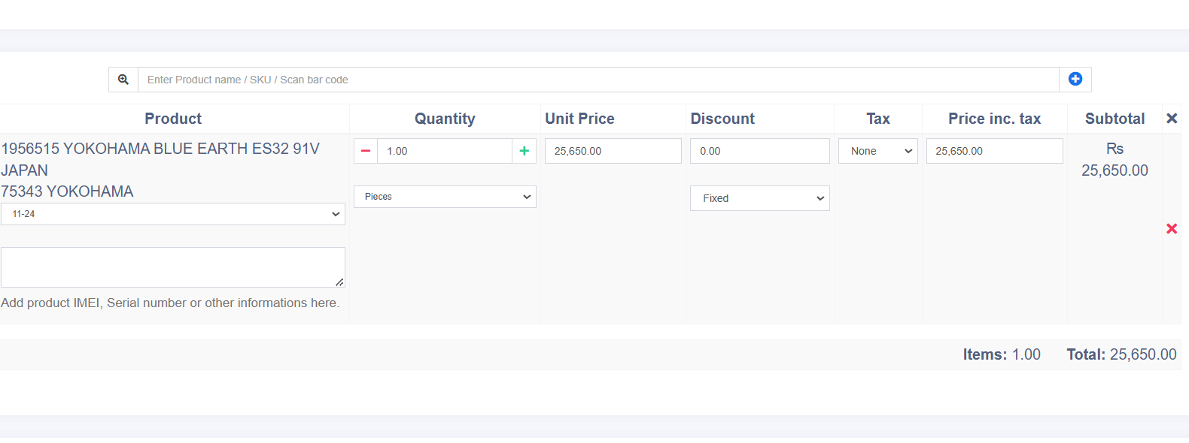
3
2
1
OLD TYRE ADJ
SALE PATTERN
JAB HUM YAHA ITEM SALE KRTE HEN
FOR EXAMPLE ITEM SALE QTY 4
AT THE SAME TIME HUM CUSTOMER SE SAME QTY IN OLD ADJUSTM BHI KRTE HEN JO KE HMRI INVENTORY MEN UPDATE HO JAYE AUR ADJUMENT AMOUNT BHI TOTAL SE MINUS HO JAYE
SALE ITEM IS NOT SEARCHABLE
JAB HUM ALL SALES ENTRIES MEN JATE HEN TO WAHAN PE HUM ITEM SOLD IN ENTRY SEARCH NAHI KRSKTE KE ENTRY KE ANDAR KON SA ITEM SALE HUA HE

PURCHASE:
YAHAN PURCHASE ADD KR KE HUM ALL PURCHASE ENTRIES MEN JATE HEN TO WAHA PE ITEM SEARCH ABLE NAHI HE KE ENTRY KE ANDAR KIA ITEM PURCAHSE HUA HAR ENTRY KHOL KE ANDAR JANA PARTA HE

COLUMNS TO HIDE:
5-6-7-8-9-10 HIDE THESE COLUMNS
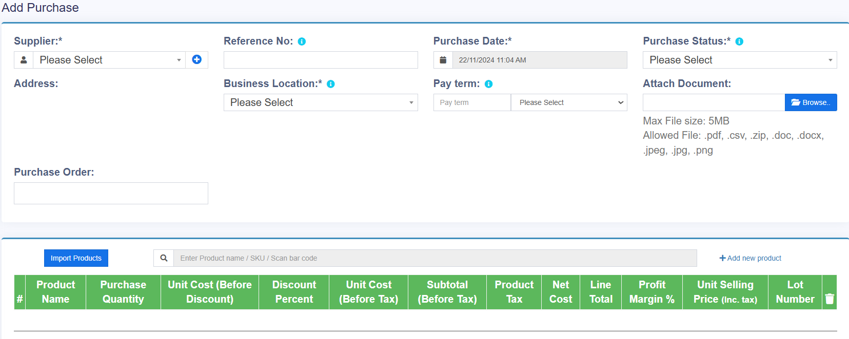

PRODUCTS:
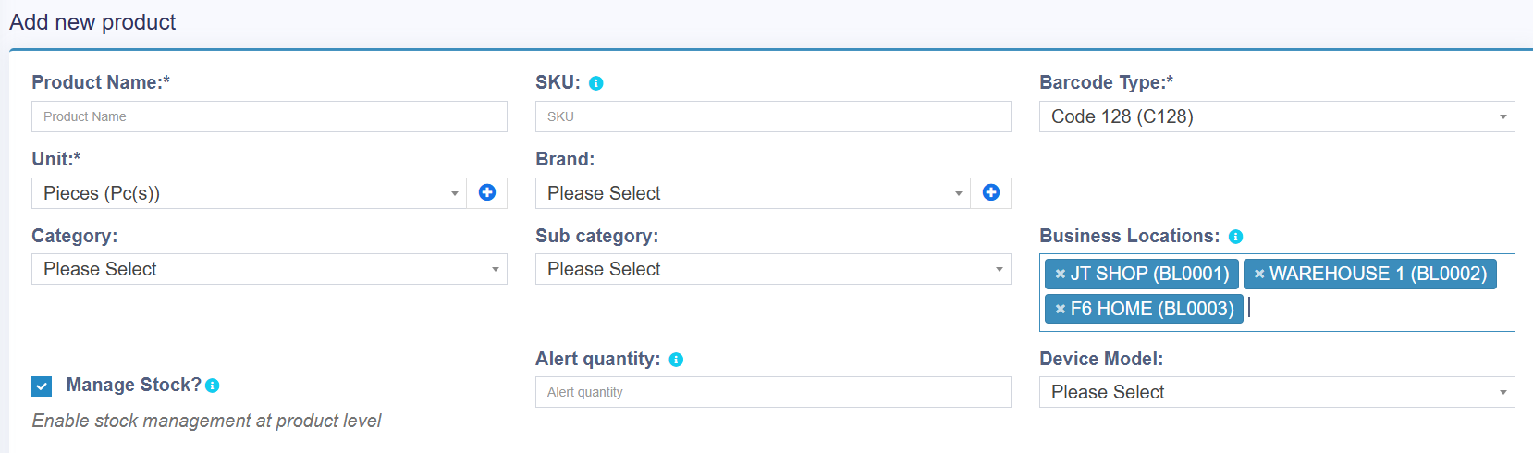
PRODUCT ADD KRTE TIME HAR LOCATION KO ALAG ALAG ADD KRANA PARTA HE SELECT ALL OPTION CHAHYE

REPORTS:
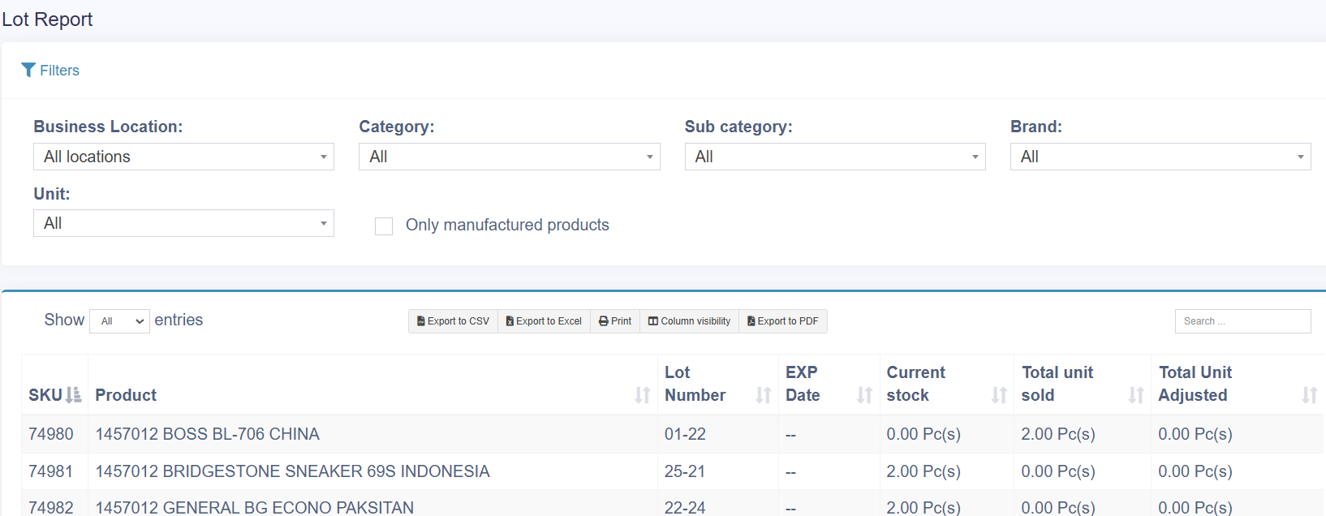

- HIDE THESE COLUMNS
- OTHER COLUMNS KO FILTER BANA DEN
- HIDE ZERO STOCKS LIKE SHOWN 0 IN CURRENT STOCK
- LOCATION COLUMN CHAHYE JO KE STOCK REPORT MEN MOJOOD HE LEKIN LOT REPORT MEN NAHI HE
- INCREASE FONT SIZE COLOR TO BLACK FULL SIZE PAGE VIEW
- KIA HUM APNI REPORT ATTACH KRSKTE HEN JIS MEN STOCK REPORT MEN HMRE MUTABIQ TABLE/FILTERS CREATE HUA HO
5II
SKU | PRODUCT | QTY | DETAIL
58155 | 1956515 YOKO | 16
SKU | PROD | LOT | LOCATION | QTY
58155 | 195651 | 44-23 | WH-1 | 4
58155 | 19565 | 11-20 | WH-1 | 3
58155 | 19565 | 10-24 | WH-1 | 9
 |  |  |  | 16
NEW PAGE OPEN BY CLICKING + DETAIL

STOCK REPORT:

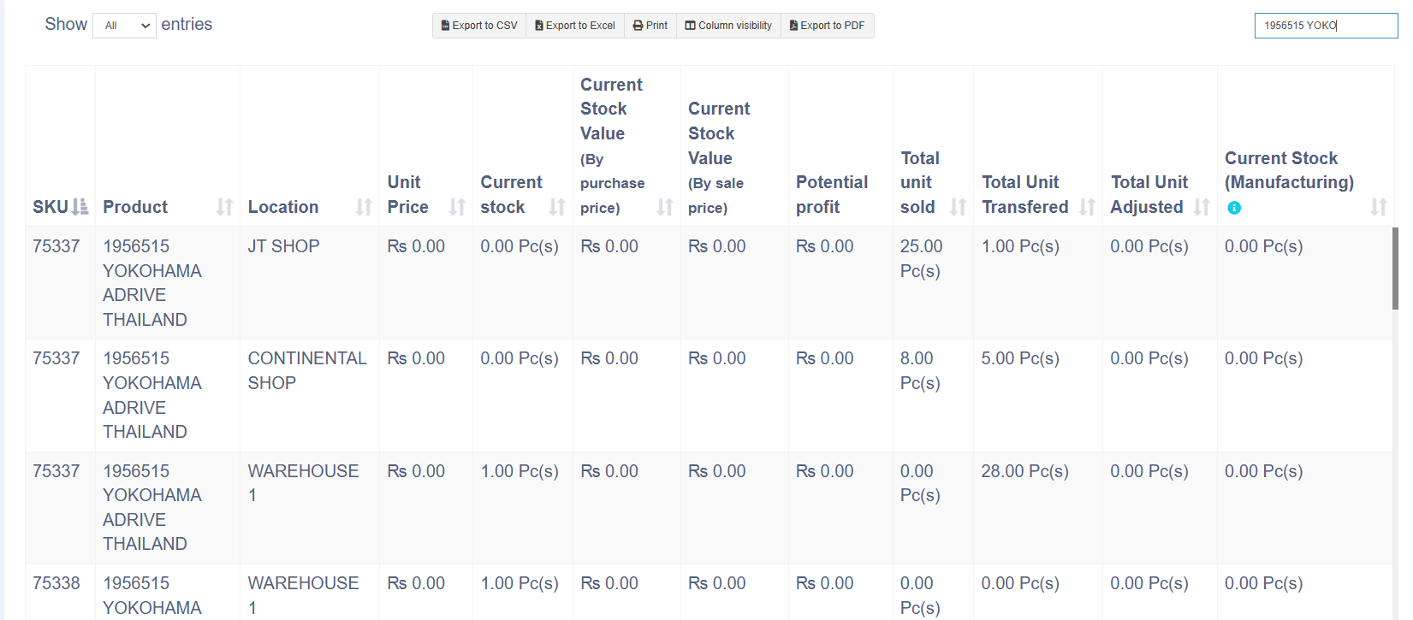
HIDE ABOVE COLUMNS

STOCK TRANSFER:
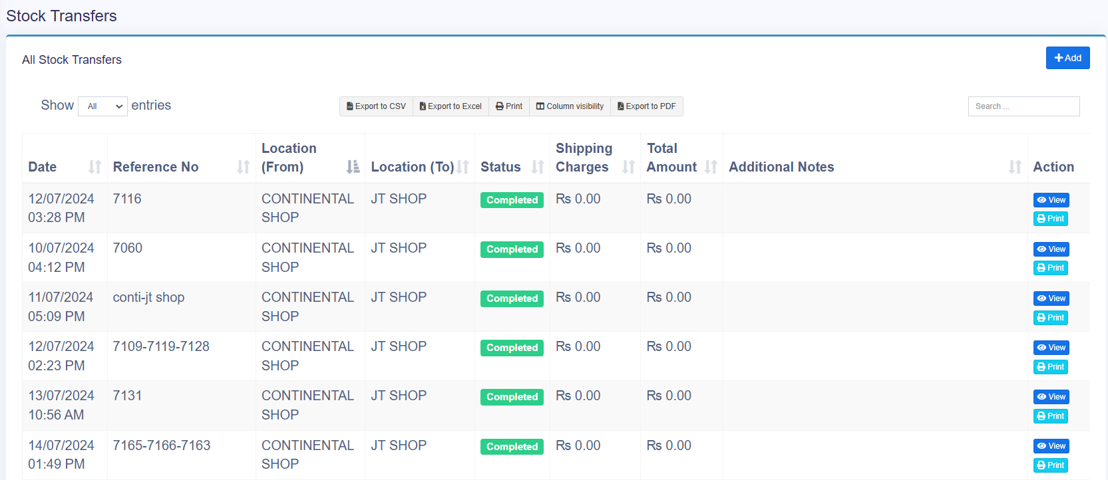
ITEM IS NOT SEARCHABLE
PRODUCT SEARCH BAR
LOCATION FILTER REQUIRED: LOCATION FROM > LOCATION TO:
DATE FILTER REQUIRED: FROM DATE > TO DATE
ITEM TRANSFERRED SHOW HONA CHAHYE KONSA ITEM TRANSFER HUA HE
HIDE COLUMN 6-7-8 ==== COMPLETE REPORT

